# Implementing Predictive Analytics for Promotion & Price Optimization

Implementing predictive analytics provides an edge to different businesses. With advancements in computing technologies and high market competition, businesses seek diverse ways to get ahead, and predictive analytics offers a trove of information to predict future outcomes. It enables data analysts and business experts to skim past real-time data and predict a customer’s future behavior. Data analysts can acquire better insight beyond comprehending a customer’s past behavior and instead use the gathered data to look forward to the future possibilities that bring success to a business.

Machine Learning, the subset of Artificial Intelligence (AI) and computing technology, can accelerate the work pace by automating all the manual operations in a business, identifying customer behavior, and improving customer satisfaction by recommending additional products. This predictive analytics guide will focus on two crucial aspects important for every business owner – promotion and price optimization – and why businesses should implement them.

**ALSO READ:**[**The Essential Components of a Successful L&D Strategy**](https://inferenz.ai/resources/blogs/learning-and-development/the-essential-components-of-a-successful-ld-strategy/)

Table of Contents

[](https://inferenz.ai/resources/blogs/predictive-analytics/implementing-predictive-analytics-for-promotion-price-optimization/)

* [Why Is Predictive Analytics Important For A Business?](https://inferenz.ai/resources/blogs/predictive-analytics/implementing-predictive-analytics-for-promotion-price-optimization/#Why_Is_Predictive_Analytics_Important_For_A_Business)
* [4 Ways to Implement Predictive Analytics in Business](https://inferenz.ai/resources/blogs/predictive-analytics/implementing-predictive-analytics-for-promotion-price-optimization/#4_Ways_to_Implement_Predictive_Analytics_in_Business)
  + [Price Optimization](https://inferenz.ai/resources/blogs/predictive-analytics/implementing-predictive-analytics-for-promotion-price-optimization/#Price_Optimization)
  + [Promotion Optimization](https://inferenz.ai/resources/blogs/predictive-analytics/implementing-predictive-analytics-for-promotion-price-optimization/#Promotion_Optimization)
  + [Supply Chain Management](https://inferenz.ai/resources/blogs/predictive-analytics/implementing-predictive-analytics-for-promotion-price-optimization/#Supply_Chain_Management)
  + [Marketing](https://inferenz.ai/resources/blogs/predictive-analytics/implementing-predictive-analytics-for-promotion-price-optimization/#Marketing)
* [Grow Sales With Inferenz’s Predictive Analytics Experts](https://inferenz.ai/resources/blogs/predictive-analytics/implementing-predictive-analytics-for-promotion-price-optimization/#Grow_Sales_With_Inferenz%E2%80%99s_Predictive_Analytics_Experts)

## Why Is Predictive Analytics Important For A Business?

With the increasing use of Artificial Intelligence and Machine Learning and the drive toward their adoption due to the benefits, the predictive analytics market size will reach [USD 28.1 billion by 2026](https://www.marketsandmarkets.com/Market-Reports/predictive-analytics-market-1181.html), states research.

Predictive analytics work by collecting, assembling, organizing, and using the ever-increasing volumes of data to draw a conclusion that leads to profitable results. The sales and marketing experts and the business team can use predictive analytics to evaluate the new pricing strategies and promotional activities to generate sales and revenue per the market trends. Some of the other benefits of predictive analytics for pricing and promotion optimization include the following:

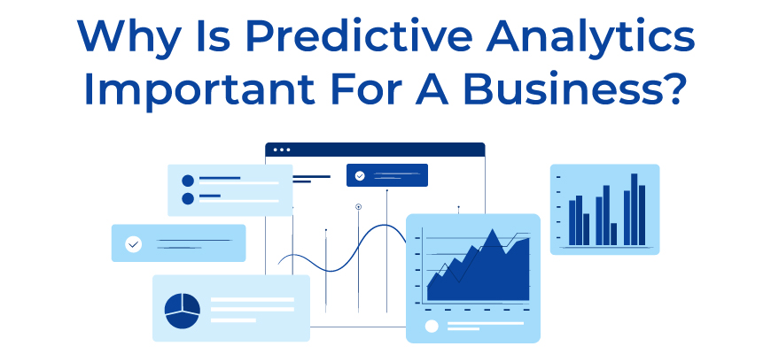

* Provides actionable insights to devise ways that help to hedge against the competition
* Saves time and business resources by eliminating the need for manual research and testing
* Reduces the cost of ineffective marketing campaigns
* Helps businesses attract, engage, and retain customers
* Analyzes the historical data of a company to identify factors that lead to product failures

## ****4 Ways to Implement Predictive Analytics in Business****

Implementing predictive analytics for promotion and price optimization will allow businesses to predict the future better and create a satisfactory user experience for their customers. Thomas Goulding, a renowned professor for the Master of Professional Studies in Analytics program, says during [his conversation](https://www.northeastern.edu/graduate/blog/predictive-analytics/) with Northeastern College of Professional Studies, “Data analytics today is allowing us for the first time to take the massive amount of data we’ve been assembling for years and use it for predictive purposes rather than in just descriptive ways.”

Here are the two ways to implement predictive analytics in one’s business.

### Price Optimization

Price optimization involves analysis of customer purchase patterns and deciding the price that maximizes the company’s revenue. Predictive analytics considers a few aspects, such as competitor’s pricing, market condition, customer demand, and more, to serve customers with the best possible price. Inferenz follows a unified analytics-based approach to implement predictive analytics that leads to improved sales, higher margins, and lower costs.

Inferenz recently worked with a Germany-based pharmaceutical company to implement predictive analytics; you can check the detailed case study [here](https://inferenz.ai/resources/blogs/portfolio/predict-health-alert-based-on-patients-vital-parameters/) and see how our predictive analytics and machine learning experts created a model that understood vital parameters for positive and negative patients.

### Promotion Optimization

By implementing predictive analytics for promotion optimization, business owners can use historical data to determine the impact of their past promotions and prepare the best future promos that save costs and maximize revenue. One can connect the promotions to inventory management to collect data and proactively ensure that the business meets promotional demand and reach its targeted price goal.

### ****Supply Chain Management****

Predictive analytics models can help businesses with supply and demand forecasting, optimize their logistics and transportation, optimize prices, and improve customer service. The historical data is carefully analyzed to predict which products are high in demand and the price customers are willing to pay.

If you want to learn how to implement the technology in SCM, read our comprehensive [predictive analytics for supply chain management tutorial.](https://inferenz.ai/resources/blogs/predictive-analytics/predictive-analytics-in-supply-chain-management-ultimate-tutorial/#Use_Cases_of_Predictive_Analytics_in_Supply_Chain_Management)

### ****Marketing****

Predictive analytics in marketing efforts is used for customer and audience segmentation based on how they will react to the advertising campaign. Many leading brands like L’Oréal are integrating the technology to predict beauty trends ahead of time and develop products that match customer expectations. Data analytics is also used in lead prioritization, churn prediction, and ad personalization.

Looking for ways to learn how predictive analytics can improve your marketing strategies and improve ROI? Check out [predictive analytics for a robust marketing strategy tutorial](https://inferenz.ai/resources/blogs/predictive-analytics/predictive-analytics-in-marketing-ultimate-tutorial-for-beginners/#Customer_and_Audience_Segmentation)here.

## Grow Sales With Inferenz’s Predictive Analytics Experts

No matter the industry, business owners can lean into data by implementing predictive analytics to gain in-depth insights into how customers interact with their business. Based on predictive models, business experts can make data-driven decisions to maximize profits and mitigate potential risks.

If you want to implement predictive analytics for promotion and price optimization, contact the experts at Inferenz.  who can not only help you evaluate the predictive model but can also devise the implementation method that best fits your business needs.

# PREDICTIVE ANALYTICS IN MARKETING

# PREDICTIVE ANALYTICS IN MARKETING

[More Marketing Analytics Topics](https://www.snowflake.com/guides/marketing-analytics)

Predictive analytics helps marketers [make better decisions today by providing insights](https://www.snowflake.com/guides/predictive-analytics-marketing?utm_cta=website-be-guides-mmds) into what’s likely to happen in the future. But many factors go into the creation of a trend, and recognizing patterns in data can be difficult given the exponential growth of data being generated from different devices and channels. [Predictive analytics](https://www.snowflake.com/guides/prediction-analytics-or-predictive-analytics) empowers marketers to make important connections in their data to improve decision-making and planning.

## WHAT IS PREDICTIVE ANALYTICS, AND WHAT ROLE DOES IT PLAY IN MARKETING?

[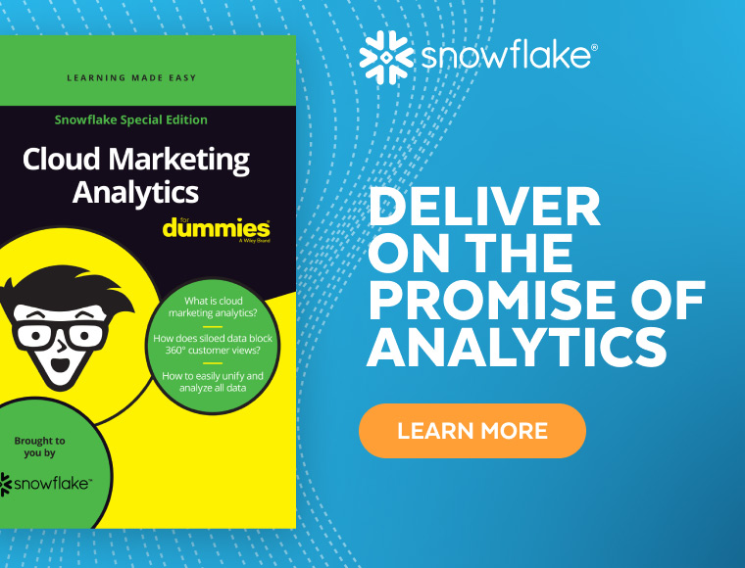](https://www.snowflake.com/resource/cloud-marketing-analytics-for-dummies-v-2/?utm_cta=website-be-guides-cloud-marketing-dummies-ebk)

Predicting the future with 100% accuracy remains out of reach no matter how much data you’ve collected and analyzed. But marketers can forecast probable outcomes with a high degree of precision using predictive analytics methods. With predictive data modeling, data gathered from in-house and third-party data sources is analyzed to uncover patterns, outliers, and other key indicators to identify likely outcomes in various scenarios.

With these insights, marketing teams optimize their campaigns to meet behavior, event-based, or revenue goals. [Artificial intelligence, machine learning](https://www.snowflake.com/trending/machine-learning-vs-ai), and historical data combine to create the kinds of data-driven insights marketers need to attract, retain, and nurture customers.

## HOW CAN PREDICTIVE ANALYTICS AID IN CREATING SUCCESSFUL MARKETING CAMPAIGNS?

Big data is the fuel powering modern marketing. Predictive analytics plays an important role in converting this data into actionable insights that improve the quality of segmentation, targeting, and promotion efforts. Here are a few ways marketers are using predictive analytics to improve their effectiveness.

### Accurately predict consumer trends

Consumer preferences are in a constant state of flux. Predictive analytics analyzes data from many sources, including contextual data such as weather and location, consumer sentiment, and online content like web pages and social media posts. Spotting an emerging trend quickly gives marketers a distinct advantage.

### Refine customer segmentation

Machine learning can help marketers improve the quality of their clustering decisions by spotting subtle relationships between data from individual customers. With this information, marketers can slice and dice customer segmentation in different ways to improve targeting and, ultimately, deliver personalized campaigns to customers and prospects.

### Create highly customized campaigns

Delivering the right message to the right customer at the right time requires customization. Predictive analytics helps marketers better understand the behavior of individuals and more accurately predict which messages are most likely to resonate with which customers, which platforms are best for effectively reaching customers, and when to launch campaigns or send offers.

### Reduce customer churn

Attracting new customers is more expensive than retaining existing ones. Predictive analytics can spot trends in customer disengagement, providing marketers with an opportunity to shore up areas of weakness such as a subpar customer service experience or a poorly performing product line. By analyzing patterns in data, these tools can also identify those customers most likely to disengage and ultimately churn. Once identified, these high-risk customers can be placed into a re-engagement program that provides personalized experiences designed to reduce attrition.

### Prepare for a post-cookie future

As the clock winds down on third-party cookies, predictive analytics and other related technologies, such as artificial intelligence (AI), will play an increasingly important role in personalizing marketing efforts. In-depth analysis of both first- and third-party data sets will become even more crucial to gain predictive insights on customer behavior, customer lifetime value, and more.

## DEPLOYING PREDICTIVE ANALYTICS TO SOLVE MARKETING PROBLEMS

Predictive analytics is being used to resolve some of the marketing industry’s most pressing challenges. Here are just a few.

### Improving marketing resource allocation

Predictive analytics tools enable marketing teams to use their resources more efficiently while increasing ROI. By accurately predicting customer behavior and segmenting for personalization, marketers can create highly effective marketing campaigns targeted only to those most likely to take the desired action—and avoid marketing spend on those unlikely to convert. Missteps are difficult and costly to correct mid-campaign, so getting all the elements of a campaign dialed in at the outset allows marketing teams to avoid wasting resources.

### Recommendation engines

Recommendation engines are designed to maximize the value of each customer and are used at various stages in the buying journey to suggest products highly likely to appeal to the individual. This strategy can increase the average value of an order significantly. Effective recommendations are based on a shopper’s purchase history data, lifestyle data, and other information to recommend only those products that closely align with their interests. Predictive analytics is used to combine relevant data and identify products that meet the criteria at hand.

### Retaining customers

Providing a seamless, engaging omnichannel experience is essential to retaining existing customers. Today consumers interact with brands across multiple touchpoints including mobile apps, ecommerce websites, social media, and in-store visits. Predictive analytics connects the data generated from each customer interaction, helping marketers provide valuable promotions and special offers to their customers across the entire ecosystem.

* A close-up of a brochure

  Description automatically generated

### Master Your Role as CM(i)O

[Read EBook](https://snowflake.hub.hushly.com/marketing/master-your-role-as-cmio)

* A book cover with a cartoon character

  Description automatically generated

### Cloud Data Analytics for Dummies

[Read EBook](https://snowflake.hub.hushly.com/marketing/cloud-data-analytics-for-dummies)

* A white and red rectangular paper with text

  Description automatically generated

### TDWI: Why the Data-Driven Marketer Needs a Cloud Data Warehouse

[Read EBook](https://snowflake.hub.hushly.com/marketing/tdwi-why-the-data-driven-marketer-needs-a-cloud-data-warehouse)

## PREDICTIVE ANALYTICS POWERED BY THE SNOWFLAKE DATA CLOUD

[Snowflake enables marketers](https://www.snowflake.com/en/solutions/for-departments/marketing/) to supercharge their marketing campaigns with predictive analytics. With the Snowflake Data Cloud, you can bring all your data together in a highly secure platform that makes governance and compliance simple. Powerful capabilities allow you to build predictive models with speed. In addition, our [partner ecosystem](https://www.snowflake.com/partners/) provides a wide range of tools and platforms to expand data analytics capabilities in the cloud. And you can enrich in-house data with third-party datasets from the [Snowflake Marketplace](https://www.snowflake.com/en/data-cloud/marketplace/).

# Predictive Analytics: Optimizing Pricing And Promotions In E-Commerce Means Combining Tools

* September 24, 2018 at 1:09 PM EDT
* By Michael Kim, AArete



Most retailers are already engaged in data analytics and predictive modeling. Today, using data to predict more successful outcomes — ultimately leading to increased sales — is not as mystifying a concept as it was even a year ago. But with a market being upended by an omnichannel imperative and consumer demand for instant gratification, how can e-Commerce retailers continuously and dynamically test out business models and strategies, refresh their questions and findings, and find out what works, particularly when it comes to pricing and promotions?

Advances in AI have a role to play here. Machine learning is very powerful in point prediction, point estimates in price — the goal being to make sure you are dynamically pricing. And it’s very effective when pricing at speed. It can help improve recommendations based on a continuous learning loop, and it’s particularly applicable in price and promotion optimization.

But the biggest challenges in pricing and promotion currently are *speed*and *innovation*. Yesterday’s pricing strategy is not going to work for tomorrow, so you have to constantly reinvent yourself. Data analytics requires a focused business strategy in order to deliver positive results, one that will allow retailers to constantly reinvent different ways of capturing and segmenting their data, analyzing it, creating new products and testing product promotions in order to stay afloat.

ADVERTISEMENT

This challenge is further complicated by the need for retailers to have an omnichannel strategy, because online crossovers may not yet always work in the store. However, when it comes to truly differentiating themselves in the market, retailers need to figure out better and stronger ways of connecting one-on-one with the consumer. And connecting the dots to accomplish this, the best approach is to employ a *combination of four strategic tools*.

## Four Pricing And Promotion Tools That Need To Work Together

Though volume-driven retailers such as **Starbucks** and **Dunkin’ Donuts** are models of pricing and promotion success, the same principles apply to any retailer. And while the hospitality industry has always led the pack in terms of pricing and personalized promotion, many industries are now learning from each other.

At the core of strategic success in pricing and promotion are an omnichannel presence, a loyalty component, a promo and coupon program, and some level of personalization. All of these can be advanced by smart use of data and predictive analytics. Let’s see how this works.

* **Omnichannel**. Whether a retailer’s business goal is to increase overall margin, grow the shopping basket in the aggregate or more granularly test one new product in a specific region, it’s now become table stakes to have an omnichannel presence. Data analytics can help retailers by helping to speed innovation and merchandising decisions.
* **Loyalty.** Taking the example of business travel, loyalty programs can vary by region, by market and of course by company. Nonetheless data analytics help to move these loyalty programs toward a more inclusive promotional view of the specific customer by automatically pulling in additional promotions and personalization.
* **Promos and Coupons**. Getting that coupon upon checking out from **Barnes & Noble** for a free cookie from the café is a certain incentive for another visit to the store. Data analytics has helped target promotions for many retailers, driving both online sales and in-store traffic.
* **Personalization.** Retailers have gotten creative about using many available channels to personalize their offers. For example, a number of small restaurants in Chicago post messages on Instagram saying, *Tag Your Friend and you’ll win a free burger.* It’s a simple concept but it exemplifies both personalization and social self-promotion; and at the end of the day, the customer gets something for free. Without data analytics, this would be impossible.

Using a combination of these four tools should help any retailer stay relevant, and predictive analytics plays a role throughout.

***Mike Kim****is a Director at*[*AArete*](https://www.aarete.com/)*, a global consultancy specializing in data-informed performance improvement, and heads its Center of Data Excellence. He can be reached at*[*mkim@aarete.com.*](mailto:mkim@aarete.com.)